Iterator
(Behavioural)

The Iterator Design Pattern in Java provides a way to access elements of an aggregate object sequentially without exposing its underlying representation. This behavioral pattern is crucial for efficient collection traversal.
Real-world example:
Imagine visiting a library with a vast collection of books organized in different sections such as fiction, non-fiction, science, etc. Instead of searching through every shelf yourself, the librarian provides you with a specific guidebook or a digital catalog for each section. This guidebook acts as an "iterator," allowing you to go through the books section by section, or even skip to specific types of books, without needing to know how the books are organized on the shelves. Each guidebook handles the traversal through its section, providing a consistent and efficient way to access the books, much like how the Iterator design pattern offers a uniform method to traverse different data structures in a software application.

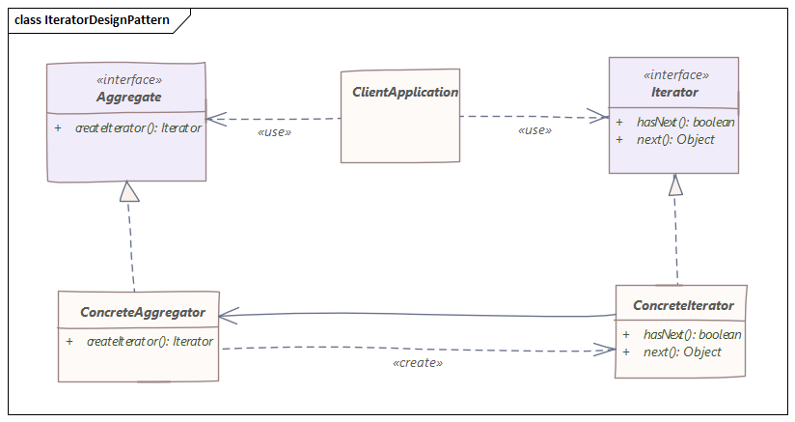

public interface Iterator<T> {
boolean hasNext();
T next();
}

public interface Container<T> {
Iterator<T> getIterator();
}

public class NameRepository implements Container<String> {
public String[] names = {"Robert" , "John" ,"Julie" , "Lora"};
@Override
public Iterator<String> getIterator() {
return new NameIterator();
}
private class NameIterator implements Iterator<String> {
int index;
@Override
public boolean hasNext() {
return index < names.length;
}
@Override
public String next() {
if (this.hasNext()){
return names[index++];
}
return null;
}
}
}

public class App {
public static void main(String[] args) {
NameRepository namesRepository = new NameRepository();
for (Iterator<String> iter = namesRepository.getIterator();
iter.hasNext();
) {
String name = iter.next();
System.out.println("Name : " + name);
}
Iterator<String> iterator = namesRepository.getIterator();
while (iterator.hasNext()){
String name = iterator.next();
System.out.println("Name : " + name);
}
}
}
Book Library Application Using Iterator Design Pattern
public class Book {

private String title;
private String author;
private double price;

public Book() {
super();
}

public Book(String title,
String author,
double price
) {
this();
this.title = title;
this.author = author;
this.price = price;
}

// setters and getters

@Override
public String toString() {
return "Book [title=" + title +
", author=" + author +
", price=" + price + "]";
}
}

public interface Iterator<T> {
boolean hasNext();
T next();
}

public interface BookCollection {
Iterator<Book> iterator();
}

public class BookIterator implements Iterator<Book> {
protected Book[] books;
protected int currentBook = 0;
public BookIterator(Book[] books) {
this.books = books;
}
@Override
public boolean hasNext() {
return (currentBook < books.length && books[currentBook] != null);
}
@Override
public Book next() {
return books[currentBook++];
}
}

public class BookLibrary implements BookCollection {
protected List<Book> books;

public BookLibrary() {
super();
books = new ArrayList<Book>();
}

public boolean addBook(
String title,
String author,
double price
) {
Book book = new Book(title, author, price);
return books.add(book);
}

public boolean addBook(Book book) {
return books.add(book);
}

public List<Book> getBooks() {
return books;
}

@Override
public Iterator<Book> iterator() {
// return books.iterator();
return new BookIterator(books.toArray(new Book[0]));
}
}

public class BookStore implements BookCollection {
protected static int MAX_BOOKS = 1000;
protected int totalBooks = 0;
protected Book[] books;

public BookStore() {
super();
books = new Book[MAX_BOOKS];
}

public boolean addBook(String title, String author, double price) {
Book book = new Book(title, author, price);
if (totalBooks < (MAX_BOOKS - 1)) {
books[totalBooks++] = book;
return true;
} else {
System.out.println(
"BookStore is full and can't accept any more books!"
);
return false;
}
}

public boolean addBook(Book book) {
if (totalBooks < (MAX_BOOKS - 1)) {
books[totalBooks++] = book;
return true;
} else {
System.out.println(
"BookStore is full and can't accept any more books!"
);
return false;
}
}

public Book[] getBooks() {
return books;
}

@Override
public Iterator<Book> iterator() {
return new BookIterator(books);
}

}

Resources:
https://java-design-patterns.com/patterns/iterator/#intent-of-iterator-design-pattern
https://dzone.com/articles/iterator-design-pattern-in-java

